Gude Balaji
9919004097
1.
Create a base class Shape with relevant data members and member functions to
get data and print the area. Create two more classes Rectangle and Triangle
which inherit Shape class. Test the classes in main method.
Code:
interface Shape{
double pi =3.14;
public double perimeter();
public double area();
}

class Circle implements Shape{
float radius;
Circle(float r){
radius = r;
}
public double area(){
return pi*radius*radius;
}
public double perimeter(){
return 2*pi*radius;
}
}
class Ecllipse implements Shape{
float a,b;
Ecllipse(float a,float b){
this.a = a;
this.b=b;
}
public double perimeter(){
return (2*pi*Math.sqrt(a*a+b*b));
}
public double area(){
return pi*a*b;
}
}
public class Main
{
public static void main(String[] args) {
Circle c = new Circle(5);
Ecllipse e = new Ecllipse(5,4);
System.out.println("area of circle is "+ c.area());

System.out.println("area of ellipse is "+ e.area());

System.out.println("perimeter of circle is "+ c.perimeter());
System.out.println("perimeter of ecclipse is "+ e.perimeter());
}
}
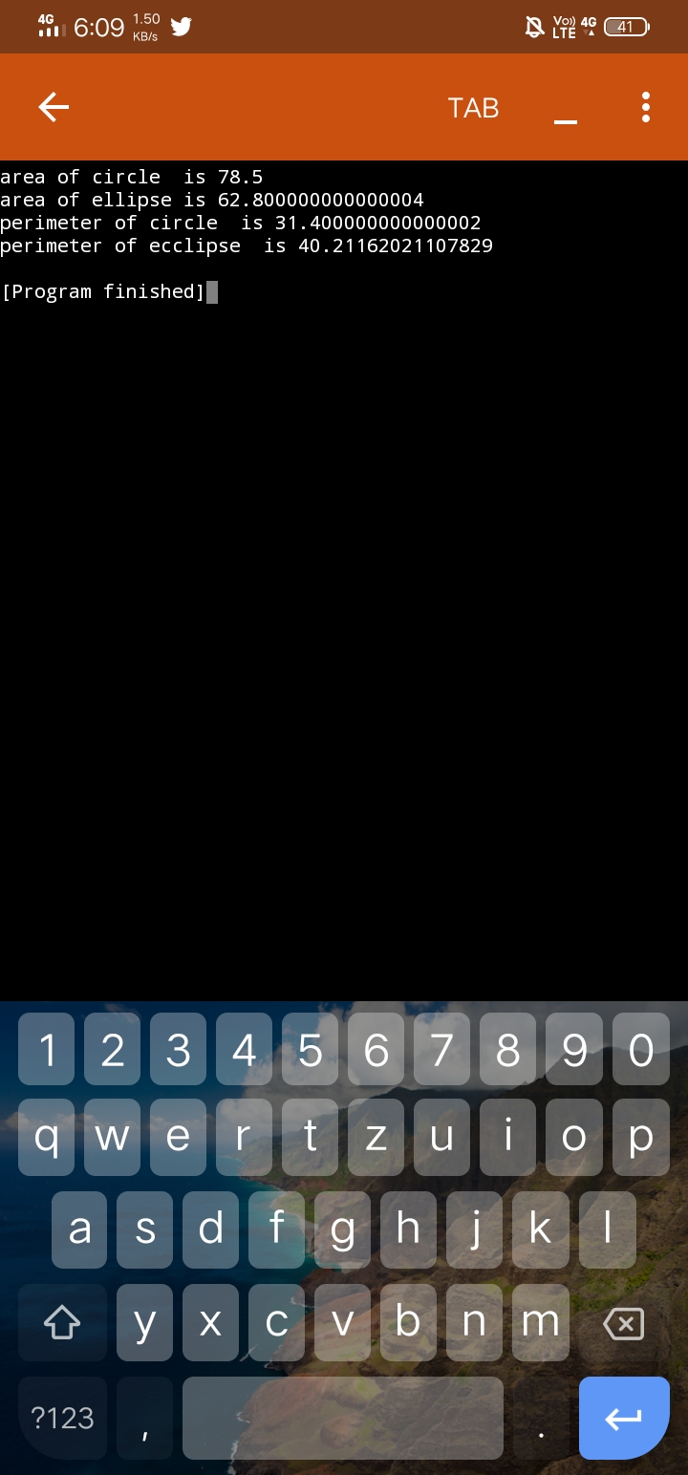

2.
Design a vehicle class that contains the following properties of motor vehicles:
Fuel tank capacity, average fuel consumption per 100 km and the distance a
vehicle can travel on a full tank. The vehicle class should be designed as a base
class from which the Car and Truck classes are derived. The derived classes
should have following member functions.
• A function that contains data for a vehicle from the user
• A function that computes and returns the distance a vehicle can travel on a
full tank.
• A function that computes and returns how many times a vehicle has to be
refueled to travel a given distance.
Test the class in the main method.
Code:
class vehicle {
int capacity;
float consumption;
float distance ;
vehicle(int c, float consume , float d)
{
capacity = c;
consumption = consume;
distance = d;
}
}

class car extends vehicle {
car(int c, float consume , float d)
{
super(c,consume,d);
}
float computeDistance()
{
float d = (capacity * 100.0f) / consumption;
return d;
}
float computeFuel(int d)
{
return d/ this.distance;
}
}

class Truck extends vehicle
{
Truck(int c, float consume , float d)
{
super(c,consume,d);
}
float computeDistance()
{
float d = (capacity * 100.0f) / consumption;
return d;
}
float computeFuel(int d)
{
return d/ this.distance;
}
}

public class Main
{
public static void main(String args[])
{
car c = new car(50,30,800);
Truck T = new Truck (50,25,700);
System.out.println("distance covered on ful tank " + c.computeDistance());
System.out.println("no of filling is required"+ c.computeFuel(800));
System.out.println("distance covered on ful tank " + T.computeDistance());
System.out.println("no of filling is required"+ T.computeFuel(800));
}
}
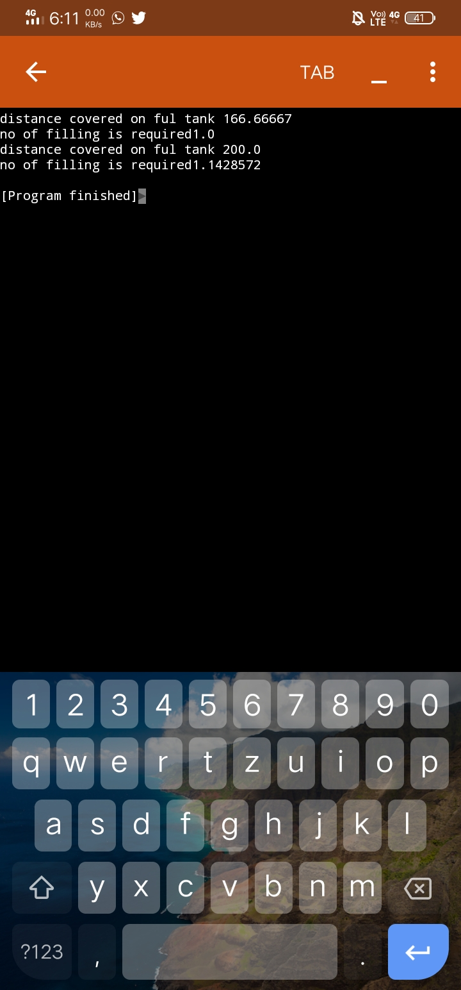
3.Create three classes Student, Test and Result classes. The student class
contains student relevant information. Test class contains marks for five subjects.
The result class contains Total and average of the marks obtained in five

subjects. Inherit the properties of Student and Test class details in Result class
through multilevel inheritances.
Code:

class Student
{
int regno;
String name, dept;
Student(int rno, String name, String dept)
{
regno = rno; this.name=name; this.dept =dept;
}
void display()
{
System.out.print(regno + " "+ name + " "+ dept);
}
}

class Test extends Student
{
int marks[];
Test(int r, String n, String d, int m[])
{
super(r,n,d);
marks = m;
}
}
class Result extends Test
{
Result(int r, String n, String d, int m[])
{
super(r,n,d,m);
}
void printResult() {
display();
int sum = 0;
for (int i =0; i< marks.length; i++)
sum += marks[i];
System.out.println(" Total Marks: "+ sum + " Average = " + (sum/5.0) );
}
}

public class TestMain
{
public static void main(String arg[])
{
int mark[]= {98,89,98,86,87};
Result r = new Result(4097, "balaji ", "CSE", mark);
r.printResult();
int mark2[] = {98,88,95,96,95};
Result r2 = new Result(4091,"mahesh", "CSE", mark2);
r2.printResult();
}
}
